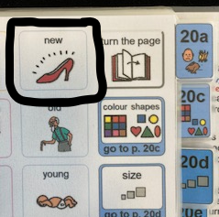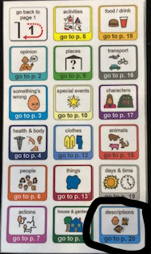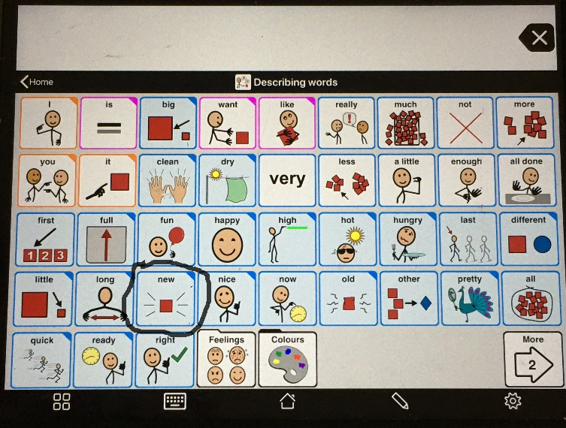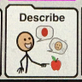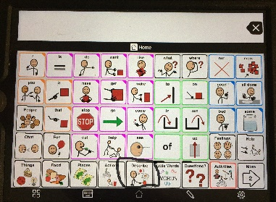

*Makaton sign*

*Widget (inPrint) symbol*

*PODD book (boardmaker)*

*Where to find it on Proloquo2go core vocabulary*

*British Sign Language*

This is the word this week, please use the word in as many moments as you can throughout the week, in the young person’s everyday life, but in activities too, using the sign or symbol:

new

Activity 1: after the weekly food shop/delivery, get foods out of the bags, commenting ‘we have new… crisps’ – repeating this for all the clearly new items.

Activity 2: find objects around the house where one is old, and one is new. Show both, but focus on labelling the ‘new’ shoe, ‘new sock’, ‘new flower’, ‘new soap’.



Activity 3: You can make two circles on the floor with a shoe lace, hoola hoop, or chalk outside. One is for the ‘new’ items, and one is for the others, the ‘old’ ones. Model putting all the ‘new’ items together in the one circle labelled ‘new’, then mix them up and let the young person have a go.



Word of the Week

new