Curriculum & Community Events 2025-2026
Term and Theme | Curriculum Events | Community Events
Autumn  Ready Steady Grow   | 1st October  International Day of Signing  | 12th December  Christmas Market  for learners, their families, staff & the local community  
10th October
The Big Draw Festival
Theme - Drawn Together

19th December
Christmas lunch & Santa
for learners & staff

21st November
Children in Need
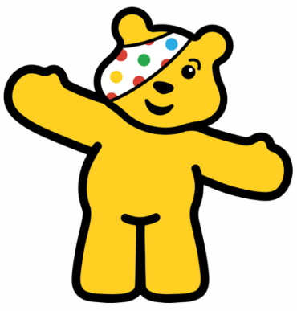
Spring  People Power   | 19th January  World Religion Day   | 27th March  Easter Market  for learners, their families, staff & the local community  
5th March
World Book Day

2nd April
World Autism Awareness Day 
Summer  Lights Camera Action   | 15th April  World Art Day   | 16th July  Leavers Celebration  for leavers, their families & staff  
 | 21st June  World Music Day   | 20th July  End of term sports / BBQ  for learners, their families, staff  

