Waynflete Road, Headington, Oxford, OX3 8DD
Telephone: 01865 767766 Email: endeavour.office@macintyreacademies.org

ENDEAVOUR HOUSE

STATEMENT OF PURPOSE

July 2019

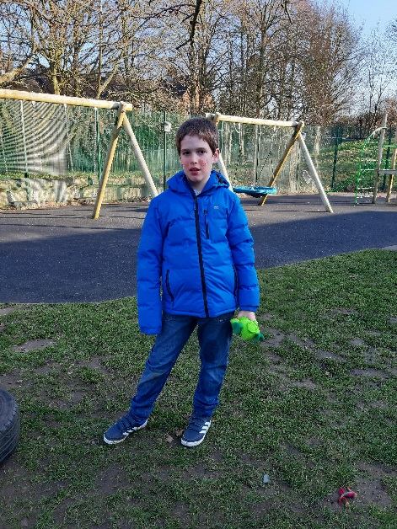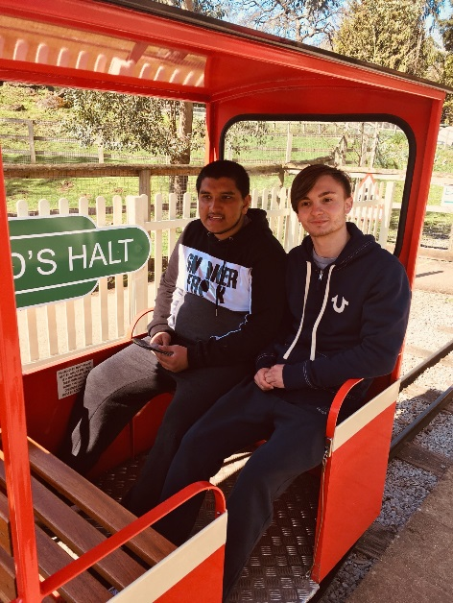
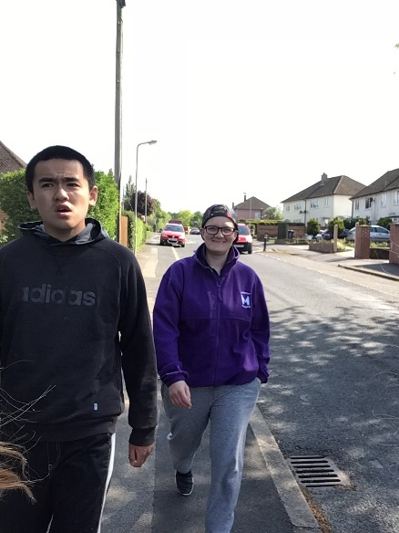

Endeavour House is registered with Ofsted as a Children’s Home
URN SC489212.

The following document is written in accordance with Schedule 1 of The Children’s Homes (England) Regulations 2015 and any amendments thereafter

CONTENTS

Quality Standard | Page Numbers
Quality and Purpose of Care | 03
Views, Wishes and Feelings | 08
Education | 10
Enjoyment and Achievement | 11
Health | 12
Positive Relationships | 13
Protection of Children | 13
Leadership and Management | 14
Care Planning | 17

QUALITY AND PURPOSE OF CARE

- Introduction to Endeavour House

Endeavour House is a Registered Children’s Home, which was established in autumn 2014 by Macintyre Academies Trust and Oxfordshire County Council as part of Endeavour Academy.

We provide accommodation and care for children and young people between the ages of eight and nineteen, who have a diagnosis of autism and moderate to severe learning disabilities. The children who reside at Endeavour House are supported in line with their Education Health Care Plans. These plans are formally reviewed at least once a year. The majority of the children and young people residing at Endeavour House are supported on a 1-1 basis, in accordance with the individual’s needs and abilities. Referrals are made through the local authority.

The Children’s Home is registered to accommodate six young people. The Short Breaks house is able to provide respite and short breaks to a maximum of six children or young people at any one time. The house is gender inclusive, with male and female students currently in residence.

- Our Ethos and Approach

Our Mission Statement is: “To help children and young people develop the skills to live a purposeful life that makes sense to them.”

We believe all young people, regardless of disability, deserve the best care possible. We want the young people we support to be ambitious for themselves and we need to be ambitious on their behalf. Endeavour House aims to provide a healthy, safe and enjoyable environment. Parents and carers are encouraged to be fully involved and connected from the outset.

At Endeavour House, we aim to:

- Value and celebrate the children and young people in our care
- Adopt a person centred approach in order to provide individualised care and support
- Know how each child and young person responds to their autism and to use that knowledge to plan to meet their needs
- Give the children and young people in our care the skills they need to manage their autism
- Improve each child and young person’s method of communication
- Promote the independence of children and young people by supporting them with daily living skills and self-care
- Help the children and young people in our care to develop skills of social tolerance and interaction
- Help meet the sensory needs of the children and young people in our care
- Help the children and young people we support to understand and learn about the world around them, providing a variety of activities and opportunities to engage with the local and wider community
- Keep the children and young people in our care safe and free from harm in a nurturing and happy environment where they know staff care about them
- Work closely with families ensuring that the key people in the children’s lives are involved in decision making and are informed of children’s progress. Families receive regular reports and photographs documenting their child’s progress, as well as being supported by staff on visits to the home or in the community.
- Promote positive behaviours through the use of positive reinforcement

Accommodation

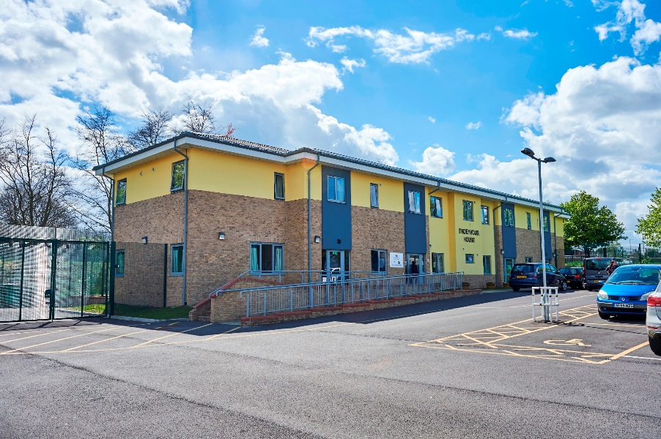

The Children’s Home and Short Breaks are set in a purpose-built modular building. There are two separate front doors and the Children’s Home is separated from the Short Breaks house by internal doors which are operated by magnetic key fobs. The Children’s Home and Short Breaks share a common room on the ground floor, which houses a computer as well as craft stations, puzzles and games. They also share a spacious and secure garden. The garden has a basketball hoop fitted on the wall, picnic benches and a swing chair which provide opportunities for social play and enjoyment. Children and young people have access to a sunken trampoline and playground within the academy site.

On the ground floor of the Children’s Home, there is a large living room, equipped with sofas, a television and DVD player, book shelves and toy boxes. The home has a small soft play area, equipped with a ball pool. There is also a dining room, where children eat their meals and snacks. The kitchen is fitted with an induction hob and oven. Entrance to the kitchen is restricted by a magnetic lock, in order to manage the risk of injury to the young people. Children are supervised when using the kitchen, and are encouraged to prepare their drinks and simple meals as independently as possible.

Within the Children’s Home, there are six bedrooms on the first floor, two of which have an en-suite bathroom. On the ground floor there is another bedroom which currently functions as a staff sleep in room. There are a further two shower rooms and one bathroom on the first floor which are shared by the children. Children’s bedrooms have been personalised with pictures, posters and wall decorations. Children are provided with furniture as appropriate such as wardrobes, chest of drawers and beds that suit their needs. The first floor of the children’s home also contains a medication room accessible by fob only, a staff office where documentation is kept.

The Short Breaks house is similar in design to the Children’s Home. There are six bedrooms on the first floor. The Head of Care’s office is also found on the first floor. On the ground floor, there is one more bedroom, which has en-suite facilities. There is also a separate toilet, large living room, dining room, and kitchen and laundry room. The laundry room is shared between the Children’s Home and Short Breaks house and is fitted with an industrial washing machine, tumble dryer and sink. The home has recently (July 2019) had air conditioning units installed to ensure that the home remains a comfortable temperature in summer months.

Location

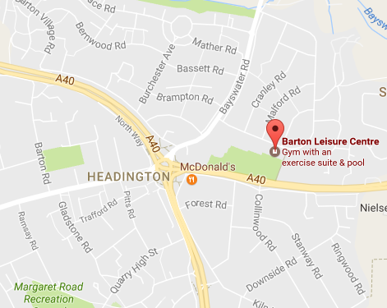
Endeavour House is situated in Barton, near Headington, on the outskirts of Oxford. The home is easily accessible by public transport - including regular public buses in and out of Oxford and frequent buses to London - and via road, making it easy for children and young people to access local amenities and for family, friends and professionals to visit the home.

There is a leisure centre with swimming pool next door to the house, shops and cafés in Barton and Headington, within walking distance and several play parks in the neighbourhood. The town centre, cinemas, bowling alleys, soft play areas, farms, country parks and supermarkets are all within easy reach by public transport or minibus.

Endeavour Academy has close links with the local police; a location assessment is completed annually, taking into account advice given by relevant local agencies.

Cultural, linguistic and religious support

Endeavour House is part of MacIntyre Academies Trust which is a non-religious organisation; as a consequence there is no religious or faith aspect inherent in day to day life. It is recognised, however, that for many people their faith, culture and first language are of utmost importance and a central part of their life and identity. Staff will do all that they can to support a young person in their faith, culture and first language whilst taking account of any special requirements, such as diet, and specific practices. They will enable them to participate within their own local faith community, and the culture and first language of their home life.

Our policy with regard to Equality of Care for young people will ensure that every child and young person’s linguistic or religious background is considered. When applicable, religious observances, dietary considerations, festivals, etc. are fully recognised, facilitated and catered for.
Prejudice in any form will not be tolerated at the children’s home.
The House has a diverse staff force with employees coming from a variety of different countries. We celebrate diversity through hosting culturally themed evenings such as Thanksgiving and Chinese New Year.

Complaints Policy

If any child or young person feels unhappy about any aspect of their placement, they can communicate their concerns to any member of staff. The house aims to hold regular keyworker sessions with each child/young person together with monthly House Meetings to provide the opportunity to raise concerns or complaints. Staff and parents/family members are encouraged to make complaints on behalf of the children and young people who are unable to verbalise complaints, staff are encouraged to view changes in behaviours as possible complaints and record appropriately.
Communication tools such as photos, symbols, PECs, are used to support children and young people to communicate their views.

More information on our Complaints Policy and Procedure is available on the Academy Website http://www.endeavour-academy.org

A complaint can also be raised independently with the Local Authority that placed the young person, or with Ofsted.

We aim to deal with all complaints/concerns in a timely manner.

Behaviour Support

At Endeavour House, staff seeks to encourage and promote appropriate behaviour and to create an environment which values and demonstrates respect for the individual. The approach of the team is based on developing positive and supportive relationships between staff and the young people in our care. It is recognised that behaviour is often a means of communication and work is undertaken with the individual to develop appropriate and socially acceptable ways of expressing wishes and feelings.

All children and young people have Positive Behaviour Support Plans that are regularly reviewed. The House enjoys strong links with external agencies such as LD CAMHS and other social and health care professionals. Any concerns raised regarding the behaviour of a young person would be reviewed as part of a multi-disciplinary meeting.

Positive reinforcement is used to influence the children and young people’s behaviour.
All staff receive training in positive behaviour support strategies that includes the use of team teach for safe use of physical intervention. Until staff receive this training they are not permitted to lead on the use of physical intervention for any child or young person. Staff attend regular refresher training.

Any physical intervention used, is recorded as part of the incident reporting process. These records are monitored by the Head of Care, Senior Managers and our Behaviour Support Lead. Records of incidents requiring physical intervention are copied to parents and placing authorities if required.

The need to use physical intervention is identified within a child/young person’s Positive Behaviour Support Plan.

Our Behaviour Management Policy and Child Protection and Safeguarding Policy can be found on Endeavour Academy website on http://www.endeavour-academy.org

Child Protection

Endeavour House has a commitment to promote and safeguard the welfare of each child and young person. In particular, our aim is to provide a safe environment that enables young people’s individual needs to be met and developed.

We believe it is vital that everyone involved in the care and support of children and young people is alert to the possibility of abusive situations.

Our safeguarding policy and procedures recognise this possibility and aim to promote an environment in which abuse is unlikely to occur. Endeavour House has comprehensive policy and guidelines (this is available on Endeavour Academy’s website) setting out the course of action for members of staff, young people and parents, visitors and friends, if abuse is alleged, suspected or observed. Endeavour Academy provides Child Protection and Safeguarding training for all staff, with regular updates and refresher training forming a part of continuing professional development (CPD).

Our Protection and Safeguarding Children Policy, and related training, reflect both national and local area guidelines. As we are located in Oxfordshire, Endeavour House follows the locally agreed procedures for this county. All allegations or disclosures in relation to child protection issues are referred directly to the Oxfordshire Local Safeguarding Board or Local Authority Designated Officer (LADO) for Safeguarding.

The Principal of the Academy acts as the Designated Child Protection Officer across the site. There are three deputy safeguarding leads across the academy, these include the Head of Care and the Safeguarding, Behaviour and Wellbeing Lead for the Academy.

Missing From Care Procedures and Protocol

As Endeavour House is registered as a Children’s Home, rather than a secure unit, we do not feel it appropriate for young people to feel restricted; and we provide many opportunities for them to enjoy the residential building and the school campus. However,
young people’s safety is paramount and all young people are supervised closely day and night.

External doors are kept locked or have access control fobs, where appropriate, as some of our children and young people lack awareness of danger and are unable to preserve their personal safety if they were to leave the building unaccompanied. These locked/access controlled external doors also protect young people from unwanted visitors/strangers entering the building.

Communication tools are used to support each child/ young person to request their wish to leave the site.

Where a young person has been known to abscond, a risk assessment will be carried out and a strategy implemented to provide more robust supervision to ensure their safety, especially when going out in the community.

On the rare occasion a child/ young person absconds, procedures are immediately instigated as follows in accordance with Oxfordshire missing from care procedures and Endeavour Academy Missing Child Policy, which is available on the Academy Website

VIEWS, WISHES AND FEELINGS

- Consulting children about the quality of their care

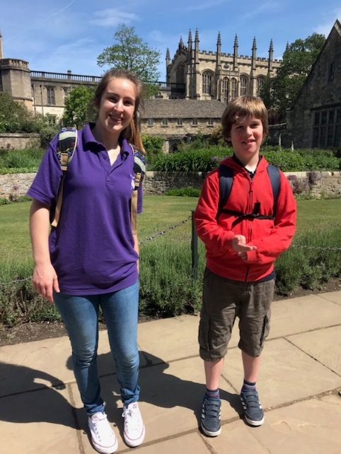

We aim to consult children about all aspects of their lives at Endeavour House. This practice is constantly evolving and developing to better meet the needs of the young people we support. The onsite Speech and Language Therapist provides advice and support about how to best ensure that the children and young people are able to contribute to their support plans and reviews.

Due to the communication support needs of many of the children who reside at Endeavour House, staff use observation as a means to assess children’s views in some instances. Concerns relating to a child’s care are raised using concern forms, which are passed to the Designated Safeguarding Lead.

Monthly House Meetings take place in order to offer children/young people a platform to express their views around their care, the activities they wish to take part in and any issues affecting the house.

Keyworkers from Endeavour House meet termly with the class teacher / keyworker in Education to discuss individual children in order to support with target setting, needs and wishes and in development of the most supportive environment and care possible around the needs of the individual.

The children and young people are visited by an independent advocate every 6-8 weeks. The advocate fulfils a “critical friend” role for the House. The advocate will review practice as well as facilitating sessions for children and young people that wish to talk with them.

- Anti-discriminatory practice and children’s rights

All children and young people at Endeavour House will be made aware of their rights and how to access support, such as the Independent Visitor, their Independent Reviewing Officer (if applicable), Children’s Rights Commissioner and Ofsted. This information is adapted to the young people’s level of understanding by our Speech and Language Therapy Team. More information is available in the Children’s guide.

A copy of the Equality and Diversity Policy is available on request from Endeavour Academy.

The expectations set out in our ethos are that every individual:

- is valued
- is treated with dignity and respect
- is safe
- is provided with emotional support
- is developed as a member of society
- can express their opinion freely and have that opinion taken into account in any decision made
- has access to appropriate information
- has access to advocacy
- is protected from abuse, neglect and exploitation
- has access to education
- is provided with the highest standards of medical and health care
- has access to leisure, recreational and cultural activities
- is protected from bullying

EDUCATION

- Provision to support children with special educational needs

Most children and young people who live at Endeavour House have a diagnosis of autism and moderate to severe learning difficulties and complex needs.

As a specialist school for Autism, Endeavour Academy is able to focus on meeting the special education needs of its young people effectively:

- The house is specially adapted to meet young people’s needs, and work closely with the education staff to ensure school attendance is high.
- Staffing levels are appropriate to provide adequate support and keep the young people safe and able to access activities that promote their development and learning.
- We have close links to a multi-disciplinary team (including Occupational Therapy, Behaviour Support, Speech and Language Therapy and Child and Adolescent Mental Health Services).
- The academy provides specialist education on site, which aids a calmer transition for the young people, and promotes good communication between the education provision and the Children’s Home.

Children have many and varied opportunities for learning at Endeavour House, whether within the Children’s Home or out in the community.

Endeavour House supports the Academy 24 hour curriculum by offering opportunities for all children and young people to develop their independence living skills, social skills and communication. All children and young people have house targets linked to their development needs

- If the home is not registered as a school, the arrangements for children to attend local schools

All of the children residing at Endeavour House attend the onsite School.

ENJOYMENT AND ACHIEVEMENT
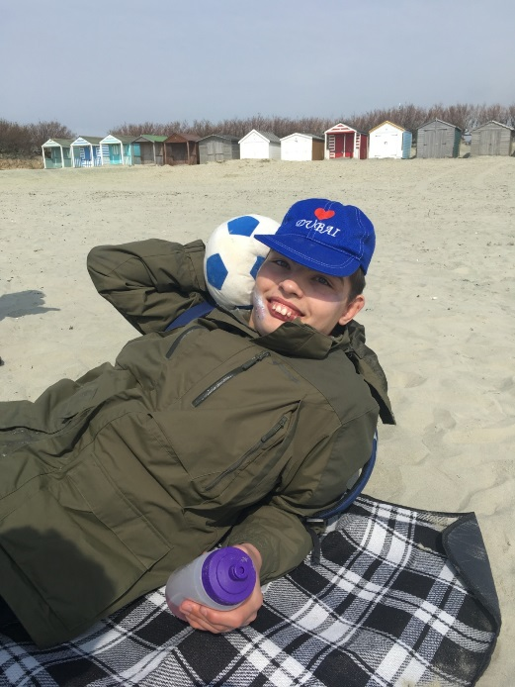
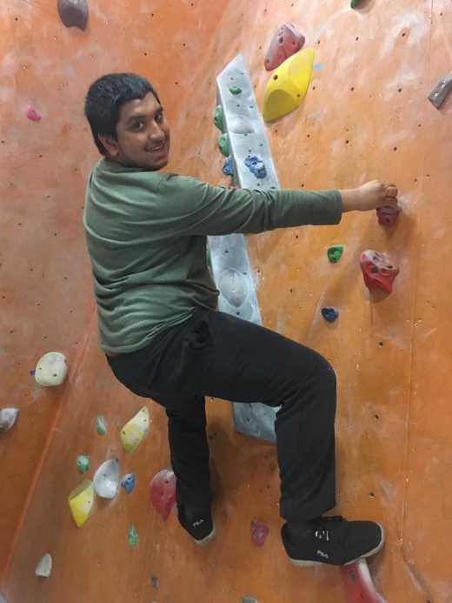

14. Participation in activities that meet children’s needs and reflect their creative, intellectual, physical and social interests and skills

Children and young people at Endeavour House have the opportunity to partake in varied activities within the house. Books, toys, musical instruments and art and craft supplies are supplied, as well as access to IT and televisions. Children are also able to access the school at weekends and in the evenings to use facilities such as the playground, which has an extensive range of play equipment – sensory room, soft play room and school hall.

Children are also encouraged to access the community to take part in activities which interest them and promote their development. Examples of these activities include:
- Swimming
- Visiting museums
- Pottery sessions
- Shopping
- Walks in country parks
- Trips to the cinema/local pubs and restaurants

HEALTH

- Healthcare and therapy
Children/young people who live in the Children’s Home are registered with a local GP practice. They attend a specialist dentist in the local area and have regular check-ups at the local optician.
To meet their specific health needs, some of our children and young people see off-site consultants and access specialist services within hospitals and clinics. These include conditions such as epilepsy and asthma. We support young people in attending these appointments.

Endeavour Academy employs a full-time Occupational Therapist. The occupational therapist is able to provide input on how to meet the differing sensory needs of the children and young people at Endeavour Academy as well as providing advice and support.

A reflexologist provides therapy to some of the children in the Children’s Home once a week after school.

Children under the care of CAMHS have regular clinic reviews held at the academy by the psychiatrist.

The Occupational Therapist carries out regular assessments and writes reports relating to the children’s progress. The reflexologist also collects data and writes reports for each child.

The children and young people have access to regular sessions with the onsite Speech and Language Therapist who delivers sessions for the children and young people at the home as well as providing staff with regular training sessions and observations of practice.

Nutrition
We believe that well prepared, wholesome and nutritious food is fundamental to a person’s health and well-being. Wherever possible we encourage children/young people to eat more whole foods and support an extensive range of diets based on medical, religious and cultural needs. The home currently cater for children and young people on halal diets and those with gluten and dairy intolerances.

Administration of Medication
All prescribed medications is administered to the children and young people, as per instructions from the prescription. It is administered by staff who have been trained and been deemed competent in the administration of medication in accordance with our policy. Parents are advised that if their child is registered with their GP at home, then medication can only be issued if we have a copy of up-to-date prescription and clearly labelled medication in original packaging. This is particularly important and relevant to our short break provision. More information can be found in the home’s medication policy (https://www.endeavour-academy.org/attachments/download.asp?file=136&type=pdf)

POSITIVE RELATIONSHIPS

- Promoting contact between children and their families and friends

Families and friends of the children are encouraged to visit regularly. Special occasions such as birthdays are also often celebrated with family within Endeavour Academy. Visits can also be supported off site, where this suits the family and the child.

Children are encouraged to write letters and cards, or emails to their family. Children may also use skype to call their family.

Key workers provide a link between the family and the Children’s Home. Key workers keep in close contact with families and seek to promote a positive relationship between the child and their family.

Staff promote positive relationships between themselves and the children and young people through celebrating achievement, organising and participating in activities, facilitating house meetings where the children and young people can feedback on their experiences of living in the home, promoting independence and respecting the children and young people’s wishes, privacy and views.

PROTECTION OF CHILDREN

- Monitoring and surveillance of children and young people

In order to keep children safe, Endeavour Academy is surrounded by a high fence and gates are locked with fob-operated magnetic locks. This means that children are unable to leave the premises without a member of staff or responsible adult. Children are supervised within the house by staff at all times.

Some of the young people attending our short break facility use an epilepsy sensor to alert staff to any potential seizure activity.
There are currently 2 surveillance cameras located at the front of the school building to monitor access in and out of the Academy campus.

LEADERSHIP AND MANAGEMENT

The leadership structure at Endeavour House is as follows

- Contact details for the Registered Provider, Responsible Individual and the Registered Manager

Registered Provider
The Children’s Home at Endeavour House is part of Endeavour Academy run by MacIntyre Academies Trust (MAT) registration number 8334745. The sponsor of the Academies Trust is MacIntyre Charity.

The MAT Head Office is 602, South Seventh Street, Central Milton Keynes, MK9 2JA. Tel: 01908230100

Responsible Individual
Rachelle Russell
MacIntyre Academies
Vernons Lane
Beaumont Road
Nuneaton
Email: rachelle.russell@macintyreacademies.org

Registered Manager
Adam Lawrence (Head of Care)
MacIntyre Academies
Endeavour Academy
Waynflete Road
Headington
Oxford
OX3 8DD
Tel: 01865 764727
Email: adam.lawrence@macintyreacademies.org

- Staff experience and qualifications

The Head of Care and Registered Manager, Adam Lawrence has worked at Endeavour House since it opened in 2014. He has completed a level 3 diploma in children and young people’s workforce and has completed a level 5 diploma in Leadership and Management in residential childcare. He has attended specialist safeguarding training provided by the local safeguarding children board. Adam holds an intermediate Team Teach instructor qualification and provides the internal training for Endeavour staff. Adam acts as one of the deputy designated safeguarding officers for the academy. Adam has completed safer recruitment training and acts as recruitment lead for the house. Adam is also a qualified Positive Behaviour Support Coach and meets regularly with the Academy Behaviour Support Team Adam also has a degree in language and communication.

Training is provided for staff, either via e-learning or face-to-face training sessions. This training may include:

- Safeguarding
- Medication
- Team Teach
- Fire Marshal training
- First Aid
- Health and Safety including Principles of Moving & Handling
- Food Safety
- Prevent Duty (Counter-terrorism)
- E-Safety
- COSHH
- Autism
- Sensory Integration
- Positive Behaviour Support
- Attachment Disorder

This list is not exhaustive.

It is expected that all staff will hold NVQ 3 or QCF Level 3 in Children and oung People’s Workforce. If they are unqualified, they are registered and begin working towards the qualification, which has to be attained within two years of employment.

- Management and staffing

The Head of Care provides direct line management to all of the staff within the home.

Supervision is carried out for all permanent staff by their line manager every six to eight weeks. This provides an opportunity for staff to discuss their personal development and engage in professional reflective practice. Performance is appraised annually in accordance with Endeavour Academy Appraisal policy. Workers from external agencies are offered group supervisions every six to eight weeks.

The House employs Team Leaders who are responsible for the operational management of each shift.

CARE PLANNING

- Criteria for the admission of children to the home

Endeavour House offers make provision to young people of either sex from eight to 19 years of age with autism and moderate to severe learning difficulties. Young people may also have associated conditions such as ADHD, epilepsy, OCD and/or other health or additional needs which may be met dependent on Endeavour Academy’s ability to provide the specialist support or specific environment required.

Referrals are made through the Local Authority and decisions on care packages are made according to the needs of the children and the families.

Staff at Endeavour House aim to work in close collaboration with social workers and other professionals involved, to dedicate time to plan admissions, involve the child and their family and offer an empathetic and caring manner.

Oxfordshire County Council, as the Local Authority, commissions overnight short break care and full time care at Endeavour House. Care is allocated on the basis of a Child and Family assessment carried out by a social worker in accordance with the Assessment Framework for the assessment of children in need and their families.

A vital element of the admission process is to assess how we support the child/young person to compatibly live alongside the young people they will be joining at Endeavour House. Careful consideration is given to the impact the child’s/young person’s admission will have on their peers and how the existing group may impact on them too. Careful planning will take place to minimise disruption to all parties.

Emergency Placements

Due to the need of the children and young people have for a planned transition, we do not take emergency admissions but can offer swift, well planned admissions, providing we have a suitable vacancy. We endeavour to work as responsively as possible with the Local Authority and with families to provide a start date as soon as is feasible, taking into account the needs of the incoming child/young person and their families and balancing this with the needs of the existing children and young people at Endeavour House.
Please note that our short-break provision is only offered to students who are already attending Endeavour Academy as a day pupil or have already been referred for a residential placement but are awaiting a suitable longer term vacancy.

